100 YEARS U.S. – HUN | Pécs 5K route description
SHORT DESCRIPTION OF THE ROUTE:
The route begins at American Corner Pécs (7621. Pécs, Zsolnay Kulturális Negyed Building No 8), by scanning the QR code placed at the entrance of the building. After scanning the first code, you will have to follow the route and scan the QR codes at each checkpoint, in the order they are marked on the map (you will be prompted to type in your runner’s ID, this will be used to calculate your lap times). The last code to be scanned will be marked as CÉL/FINISH. Once you scan this code, the system automatically records your run, and it will be visible on the leaderboard. If you miss a checkpoint, your run will be disqualified.

PLACEMENT OF THE QR CODES AND THE ROUTE:
In order to successfully complete the run, you will have to scan 4 QR codes and enter your “Runner’s ID” at each checkpoint. The run starts at American Corner Pécs, in the Zsolnay Quarter. You will find the exact location of the building on the map here:
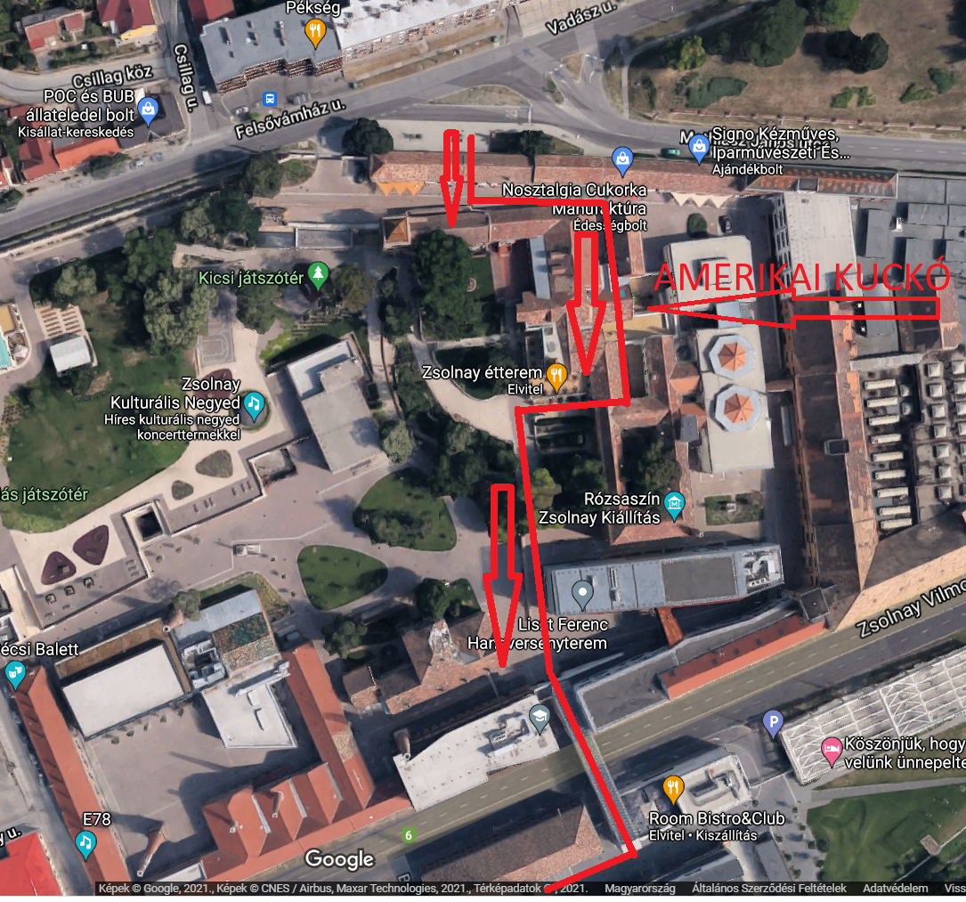
Enter through the North-entry (Felsővámház street) and turn left, then go down the stairs to the right of the candy shop (yummy!). You’ll get to a small backyard where you can find the building of American Corner. The START / FINISH QR codes are placed on the Corner’s door.
1. START:
(a photo of each QR code’s exact location can be found in the downloadable document)
The code that starts the run can be found on the door, next to the poster about the AMERICAN CORNER (make sure you don’t scan the FINISH code right next to it!).
Scan the QR code with your phone, open the pop-up site and enter your runner’s ID (this is the code you received when you signed up for the run; you can find it in your runapest.hu account). Once you type in your ID, you will get a “Run started successfully!” (Sikeres indulás!) message.
American Corner Pécs is a cultural and educational center that provides programs that introduce the local community and individuals to American society, culture and democratic values.
Follow the route and run across the Zsolnay Quarter (marked in the upper picture), then go across the Bridge-building above Route 6. You will have to turn and go alongside Route 6 (make sure you observe all traffic laws). You will reach the first checkpoint in a few hundred meters.

2nd QR CODE: FIRST CHECKPOINT
(a photo of each QR code’s exact location can be found in the downloadable document)
Our first checkpoint, Breuer Marcell avenue, goes past the Kodály Center. The QR code can be found on the sign at the main entrance of the Kodály Center.
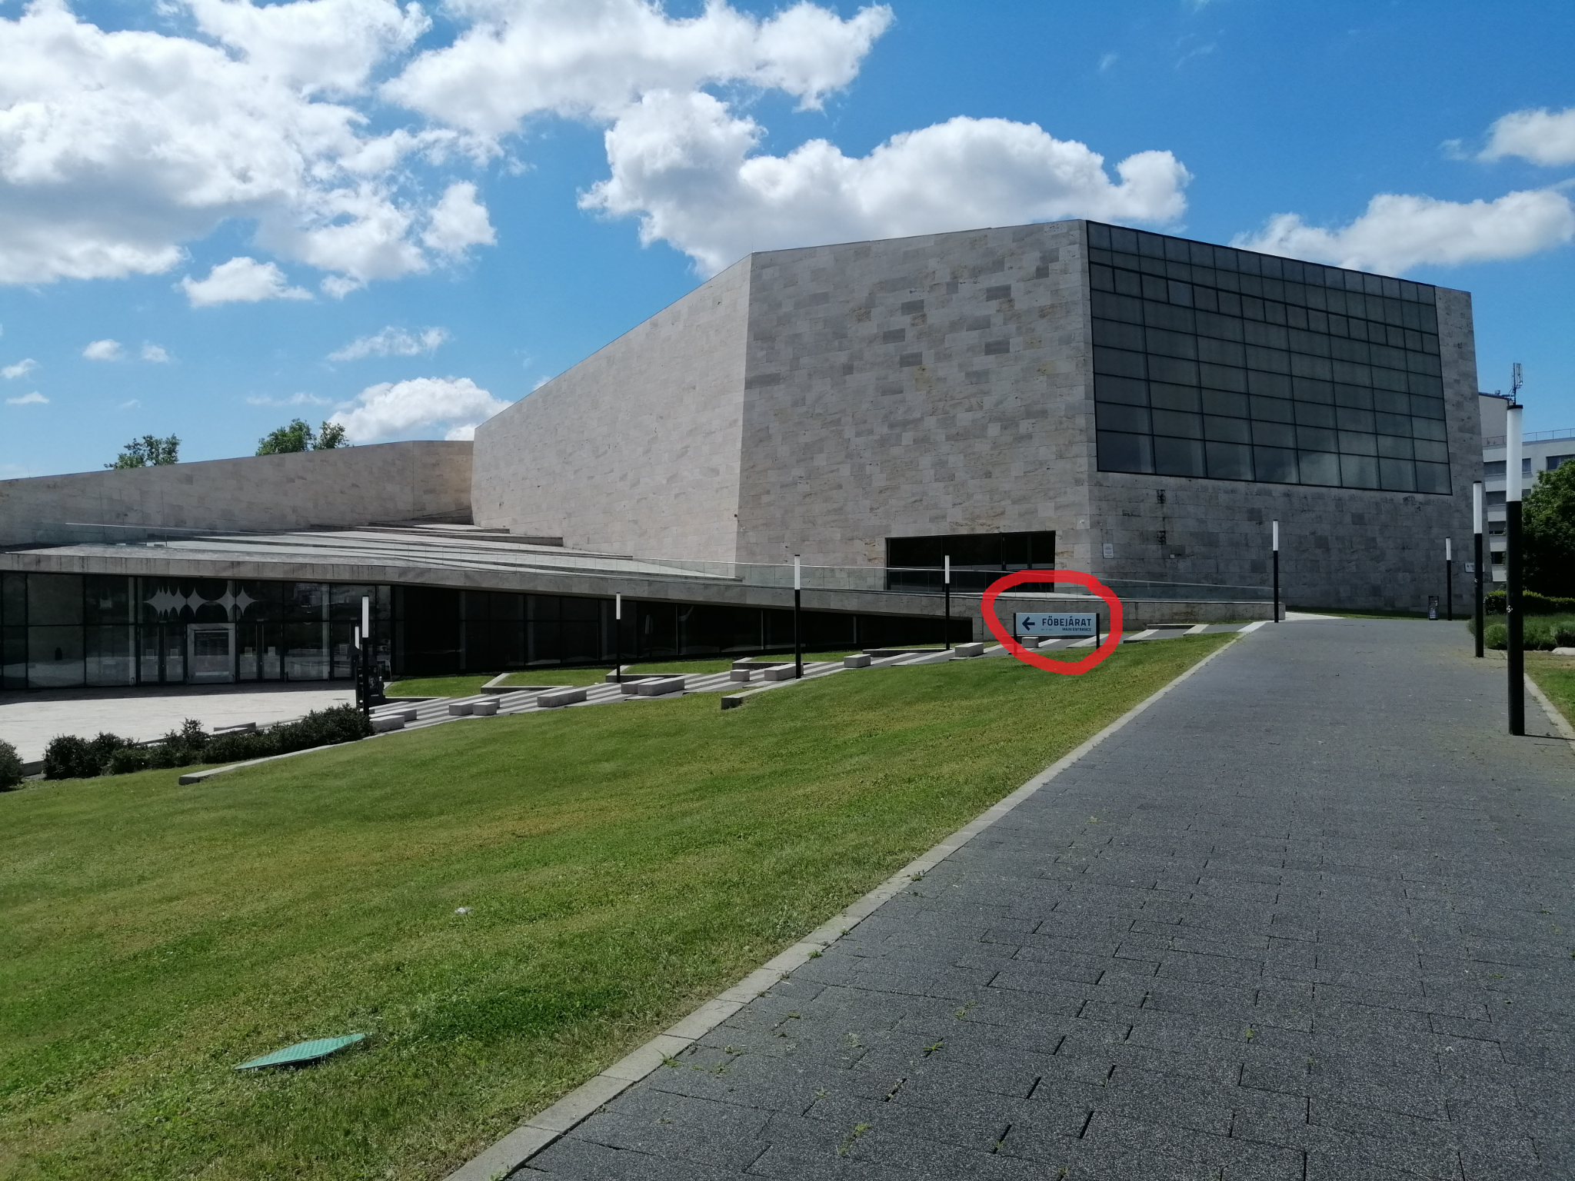

You will have to enter your runner’s ID once again (most devices will remember it and offer to autocomplete), and you will get a “Code scanned successfully!” (Sikeres beolvasás!) message.
Marcell Breuer, Hungarian-born architect, moved to the U.S. in 1937. He designed the Washington, D.C., headquarters building for the U.S. Department of Housing and Urban Development which was completed in 1968.
After taking a good look at the Kodály Center, you can continue your run along the route, the second checkpoint will await you in the city center.

3rd QR CODE: SECOND CHECKPOINT:
(a photo of each QR code’s exact location can be found in the downloadable document)
The QR code can be found on the left-side window of the bookstore located at the House of Art and Literature. The process of scanning the code is the same as for the first two codes.
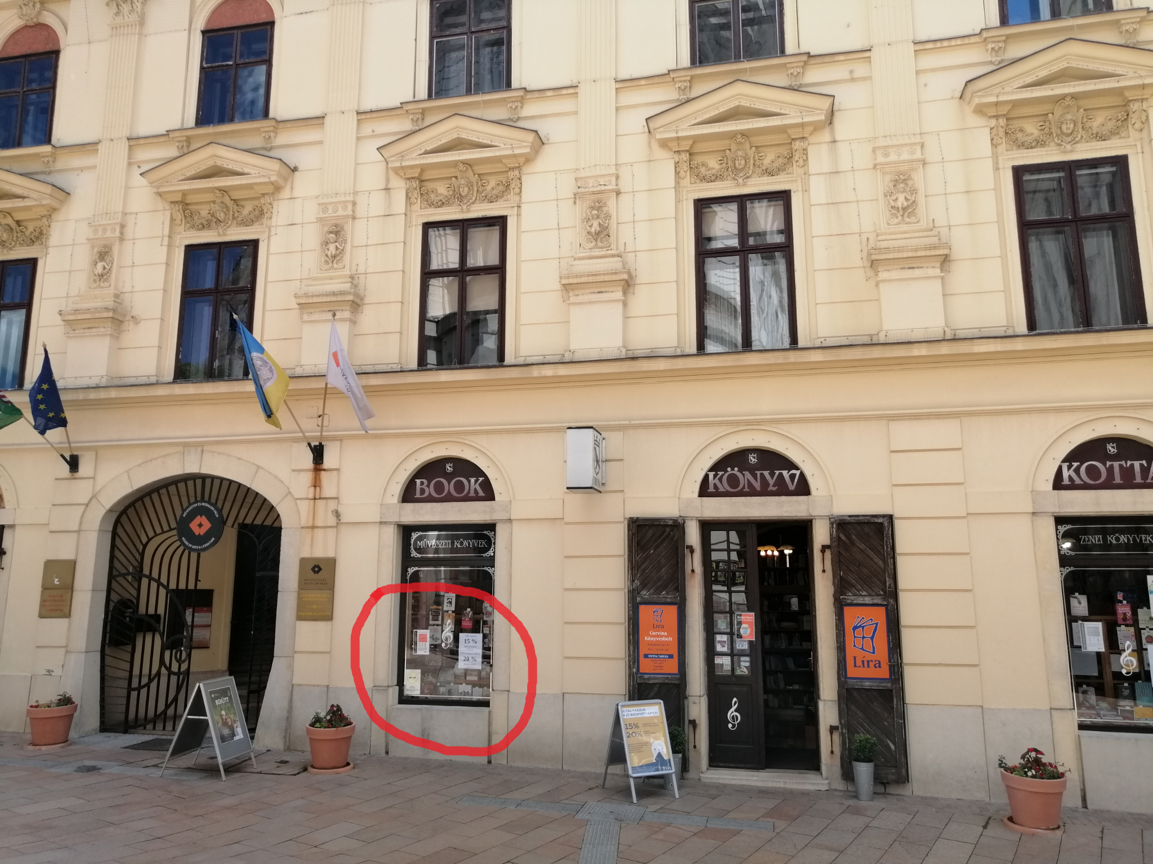

American Corner Pécs held multiple programs at the House of Art and Literature, including their Welcome, Mr. President! exhibition in 2010, which highlighted visits of U.S. presidents to Hungary using archive press photos.
Follow the route and run past the Pécs Cathedral, then back to the Mosque, and then you’ll run along the pedestrian-zone towards the finish line. All excellent spots to take a selfie to be posted on Facebook 😊. #picoritdidnthappen 😊Use the #USAHungary100years #EgyesültÁllamok100 és #HUSA100 hashtags.
Follow the route and run towards the finish line, and once you are back at the Zsolnay Quarter, scan the FINISH code.

4th QR CODE: FINISH
(a photo of each QR code’s exact location can be found in the downloadable document)
The FINISH code can be found next to the START code. If you scanned all the codes correctly, and entered your ID, you will get a pop-up message saying that you successfully completed the run. You will also see your run time.
Congratulations on completing your run! We hope you’ll join our other events celebrating the 100 year anniversary of diplomatic relations between the U.S. and Hungary.
The first 500 runners who successfully complete the run can pick up their medals at the times specified on the website.
In case you encounter any problems or have any questions, call Máté Karlovitz at +36 20 460 5191

